
NATIONAL INSTITUTE OF TECHNOLOGY PUDUCHERRY
(An Institution of National Importance under MHRD, Govt. of India)
KARAIKAL – 609 609

DEPARTMENT OF COMPUTER SCIENCE AND ENGINEERING
Roll Number: | CS19B1016 | Name | BOYINA AJAY SANTHOSH
Semester: | II | Class: | B TECH 1ST YEAR
Subject Code: | CS106 | Subject Name: | DATA STRUCTURES LABORATORY

9. ADDITION OF TWO POLYNOMIALS
THROUGH LINKED LIST
Date:30.2.20

AIM:
To get a resultant polynomial from adding two polynomials through linked lists.

ALGORITHM:
1. create the own data type struct node.
2. in that data type declare variables coefficient, degree and node pointer next.
3. create two polynomials through linked lists
4. now go into the function addpoly.
5. now compare the degree of node1 of linked list1 and degree of node1 of linked list2.
6. now create another linked list and store the value of more degree, and thats coefficient in the newnode of new linked list.
7.continue this process until anyone of the linked list is empty.
8.now store the values of coefficients,degrees of non empty linked list to the nodes of new linked list.
9. now print the coefficients,degrees respectively of new created linked lists
10. this give the resultant polynomial ( results from adding of two polynomials)

PROGRAM:

#include<stdio.h>
#include<stdlib.h>
struct node
{
int cof,deg;
struct node *next;
};
typedef struct node nd;

nd *addpoly(nd *head1,nd *head2,nd *newhead);
void display(nd *newhead);
nd *linkedlist1(nd *head1)
{
nd *newnode1,*temp;
int choice;
head1=NULL;
do
{
newnode1=(nd *)malloc(sizeof(nd));
printf("enter choice\n");
scanf("%d",&choice);
printf("insert cof and deg:\n");
scanf("%d%d",&newnode1->cof,&newnode1->deg);
newnode1->next=NULL;
if(head1==NULL)
{
head1=newnode1;
temp=newnode1;
}
else
{
temp->next=newnode1;
temp=newnode1;
}
}while(choice!=0);
temp=head1;
while(temp!=NULL)
{
printf("%d is degree and %d is coefficient\n",temp->deg,temp->cof);
temp=temp->next;
}
printf("head points to %d\n",head1);
return head1;
}
nd *linkedlist2(nd *head2)
{
nd *newnode;
nd *temp;
int choice;
head2=NULL;
do
{
newnode=(nd *)malloc(sizeof(nd));
printf("enter choice\n");
scanf("%d",&choice);
printf("enter cof and deg\n");
scanf("%d%d",&newnode->cof,&newnode->deg);
newnode->next=NULL;
if(head2==NULL)
{
head2=newnode;
temp=newnode;
}
else
{
temp->next=newnode;
temp=newnode;
}
}while(choice!=0);
temp=head2;
while(temp!=NULL)
{
printf("%d is coef and %d is deg \n",temp->cof,temp->deg);
temp=temp->next;
}
printf("head of second linked list points to %d\n",head2);
return head2;
}
int main()
{
nd *head1=NULL;
nd *head2=NULL;
nd *newhead=NULL;
nd *newnode1;
nd *newnode2;
head1=linkedlist1(head1);
head2=linkedlist2(head2);
newhead=addpoly(head1,head2,newhead);
display(newhead);
return 0;
}
nd *addpoly(nd *head1,nd *head2,nd *newhead)
{
nd *t1,*t2,*t3;
int k;
t1=head1;
t2=head2;
while(t1!=NULL && t2!=NULL)
{
if(newhead==NULL)
{
newhead=(nd *)malloc(sizeof(nd));
t3=newhead;
}
else
{
t3->next=(nd *)malloc(sizeof(nd));
t3=t3->next;
}
if(t1->deg>t2->deg)
{
t3->deg=t1->deg;
t3->cof=t1->cof;
t1=t1->next;
}
else
{
if(t1->deg<t2->deg)
{
t3->deg=t2->deg;
t3->cof=t2->cof;
t2=t2->next;
}
else
{
if(t1->deg==t2->deg)
{
t3->deg=t1->deg;
t3->cof=t1->cof+t2->cof;
t1=t1->next;
t2=t2->next;
}
}
}
}
while(t1!=NULL)
{
if(newhead==NULL)
{
newhead=(nd *)malloc(sizeof(nd));
t3=newhead;
}
else
{
t3->next=(nd *)malloc(sizeof(nd));
t3=t3->next;
}
t3->deg=t1->deg;
t3->cof=t1->cof;
t1=t1->next;
}
while(t2!=NULL)
{
if(newhead==NULL)
{
newhead=(nd *)malloc(sizeof(nd));
t3=newhead;
}
else
{
t3->next=(nd *)malloc(sizeof(nd));
t3=t3->next;
}
t3->deg=t2->deg;
t3->cof=t2->cof;
t2=t2->next;
}
t3->next=NULL;
return newhead;
}
void display(nd *newhead)
{
nd *t4;
t4=newhead;
printf("\n");
printf("the resultant exp is :\n");
while(t4->next!=NULL)
{
printf(" %dx^%d +",t4->cof,t4->deg);
t4=t4->next;
}
printf(" %dx^%d.",t4->cof,t4->deg);
}

OUTPUT:

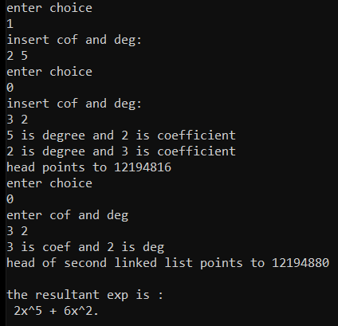

RESULT:

The program is successfully executed.

